Lattice Multiplication
A fun and easy way to multiply bigger numbers
Let's do one with bigger numbers!
Get it set up!

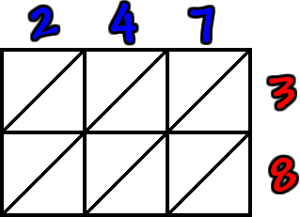

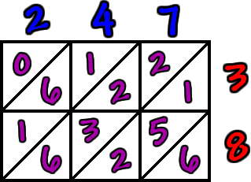
Make your matches and multiply:

,
,
,

Start at the bottom and add down the diagonal stripes... But, look what happens when we hit the yellow diagonal stripe!

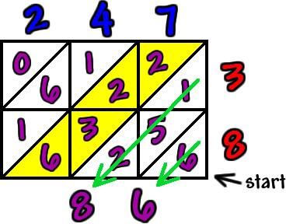
We get a get a two digit answer... So, we just need to carry into the next diagonal stripe. It's the same thing we do with regular addition!

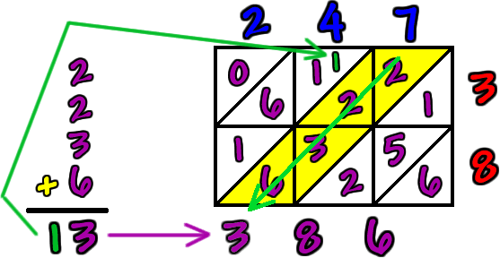
Now, finish it off!
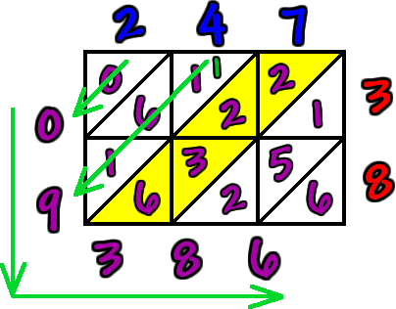

Pretty cool, huh? Try some yourself! You can check your answers using a calculator or the regular way of multiplying.

