[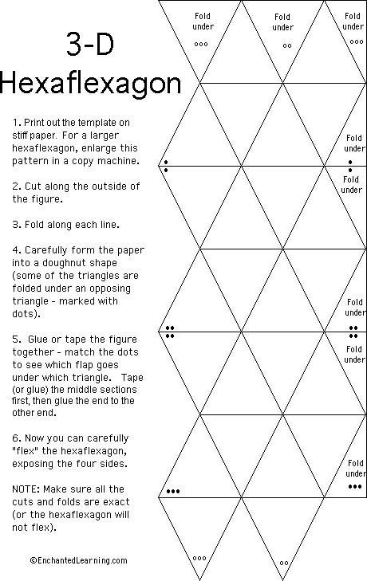](http://www.enchantedlearning.com/math/geometry/hexaflexagon/instructions.shtml)