MEDIEVAL MATHEMATICS - FIBONACCI
Leonardo of Pisa (Fibonacci) (c.1170-1250)
What is Lattice Multiplication and where does it come from? Good question! Lattice multiplication is a process that was first founded in the 10th century in India. This method was later adopted by Fibonacci in the 14th century and seems to be becoming the "go-to" method in teaching elementary students how to multiply two numbers in which at least one of them is a two-digit number or greater. This process uses the exact same algorithm you probably learned in your own elementary classes, but organizes it into a box; thus, this is why many people also refer to this method as the "box-method". Through the use of the distributive property, we can use this same process for any type of multiplication problem. This method not only teaches students on how to multiply two larger numbers, but also allows them to work on their organizational skills and practice identifying the place value of a given number. Now that we know what lattice multiplication is and where it comes from, let's look at a specific example.
Fibonacci is best known, though, for his introduction into Europe of a particular number sequence, which has since become known as Fibonacci Numbers or the Fibonacci Sequence. He discovered the sequence - the first recursive number sequence known in Europe.
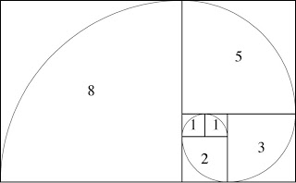
1, 1, 2, 3, 5, 8, 13, 21, 34, …..

